1) Create on Bash script to check if a directory is available or not.

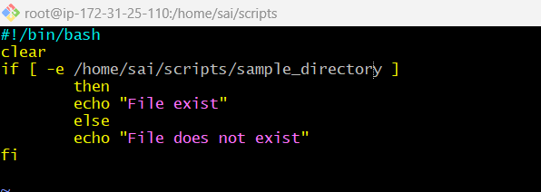

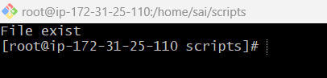

2) Create a bash script which will create multiple files.

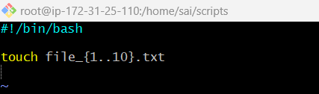



3) Create a bash script to take backup of a directory.

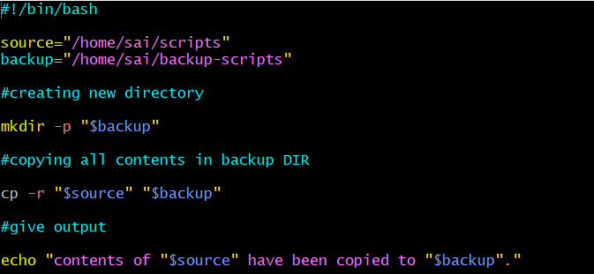

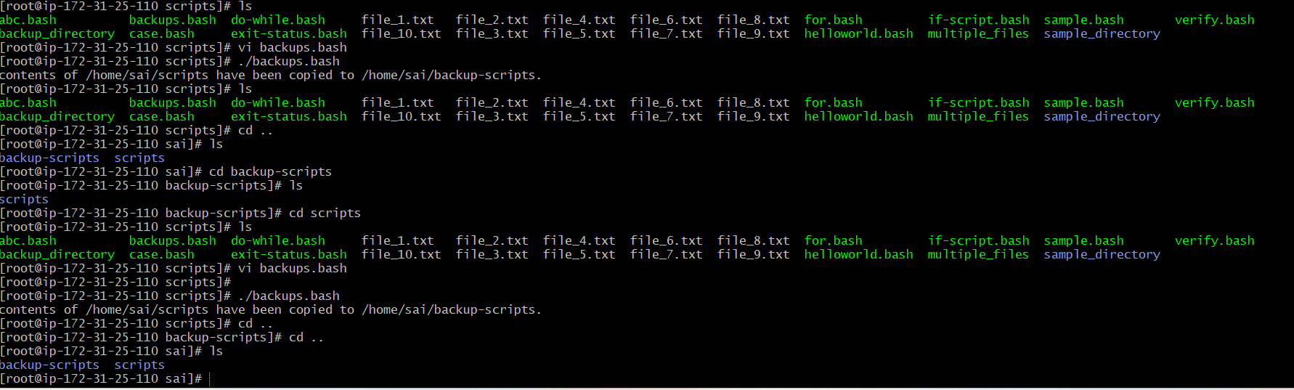

4) Create a bash script to install nginx in ec2 server.

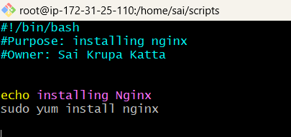

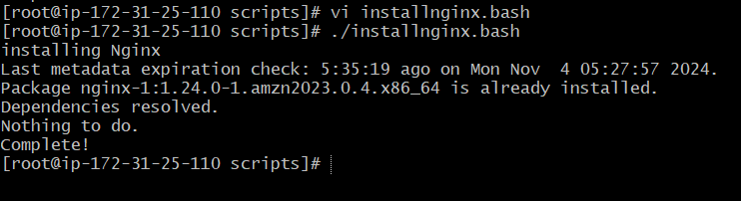

5) Create a bash script to install ApacheTomcat in ec2 server.

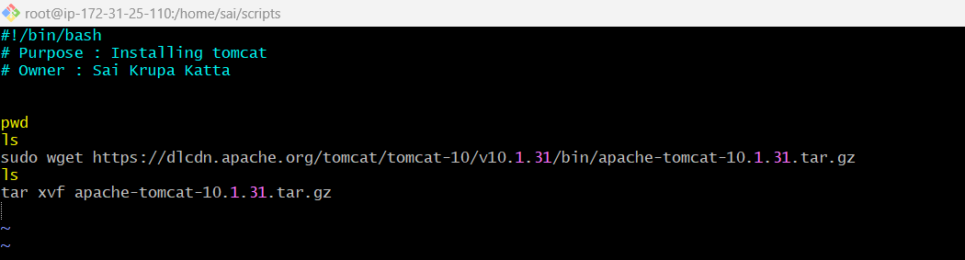

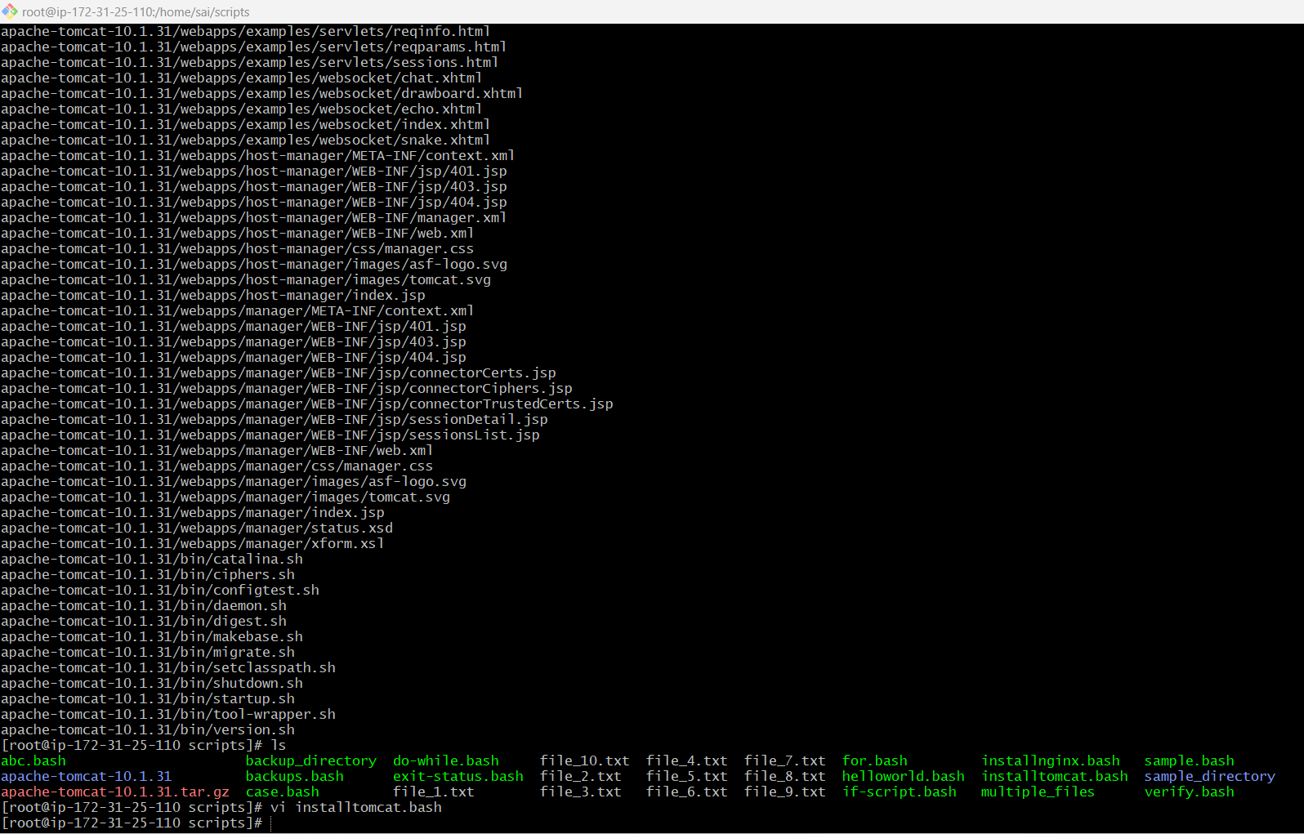

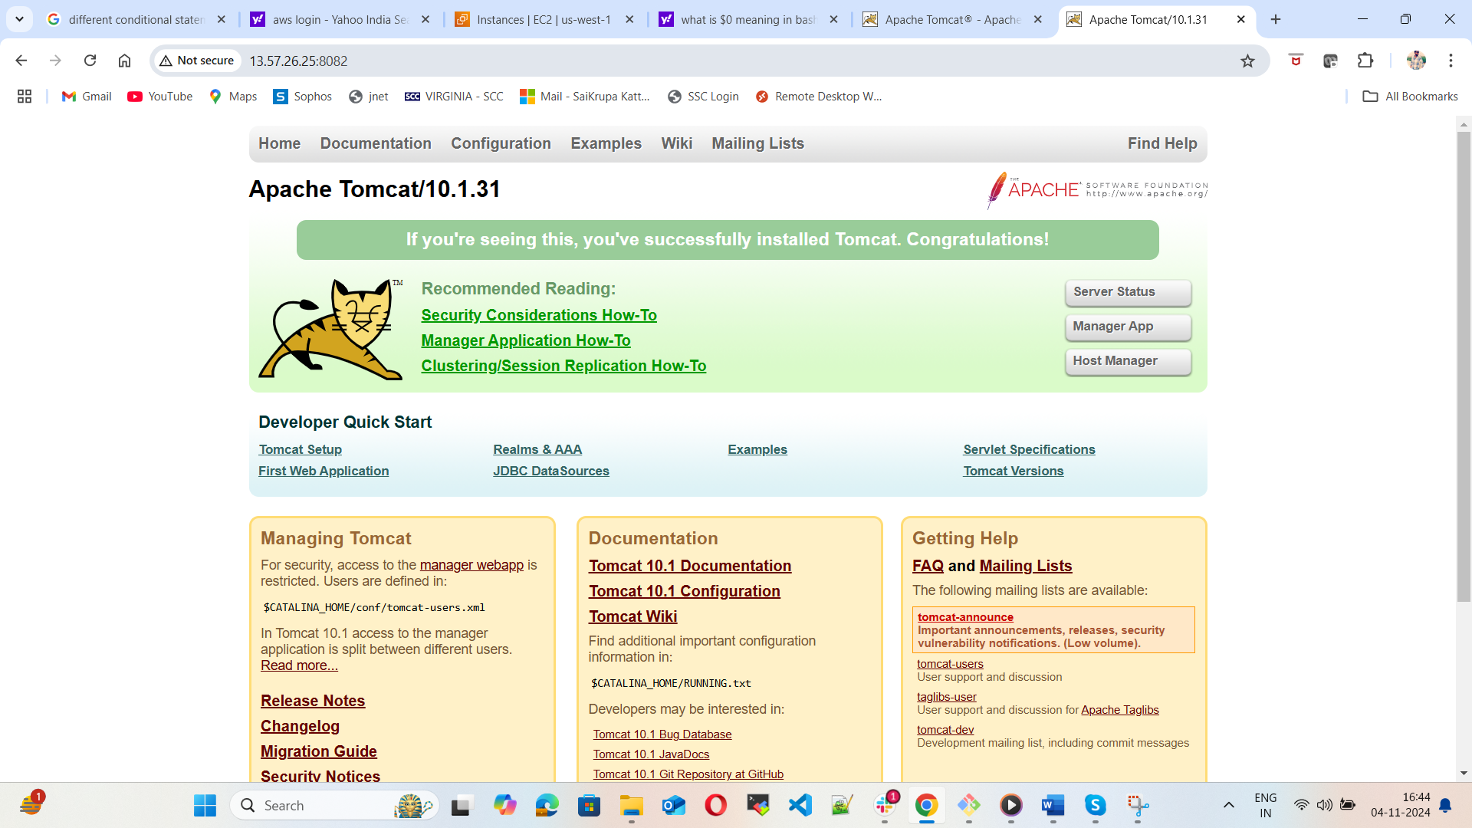

6) Create a bash script to check list if nginx service is running or not,if not running then script should start the service.

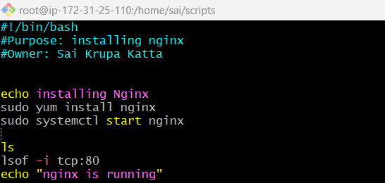

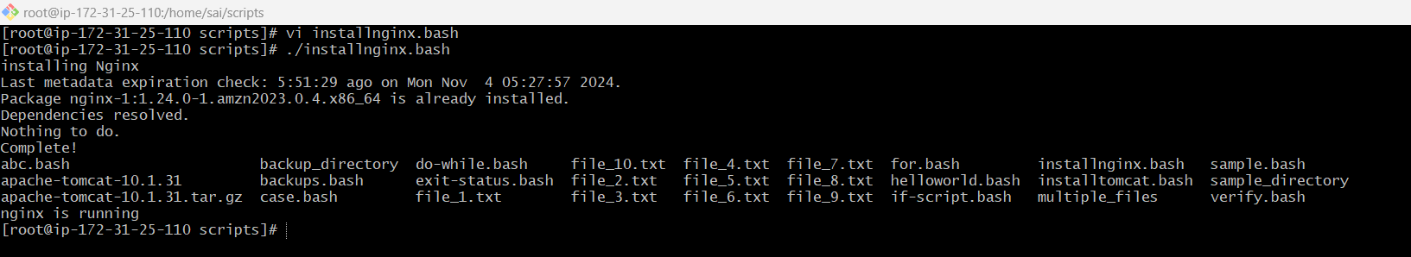

7) Create a bash script for calculator.

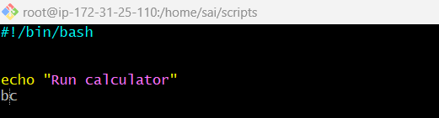

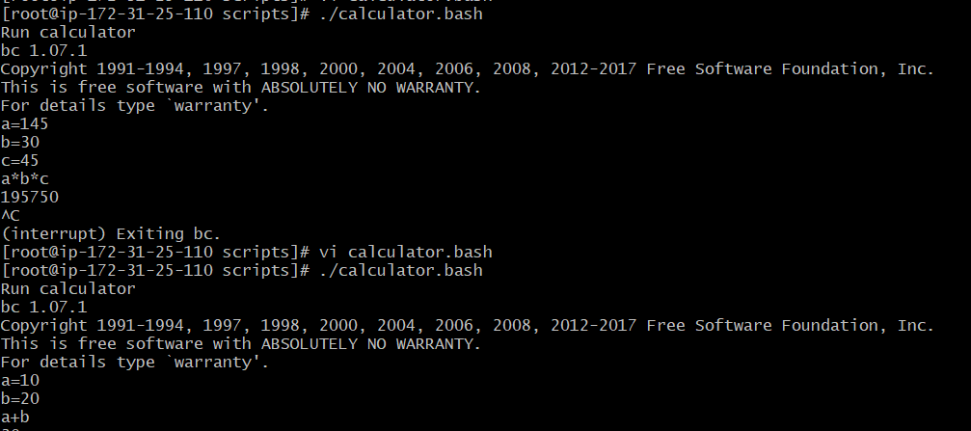

8) Create a bash script to check if directory is available or not, if not then create a directory.

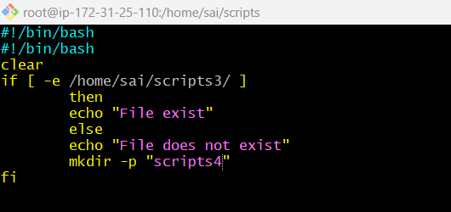



9) Create bash script to delete last 3 lines for a file. Exercise Crontab Entries:

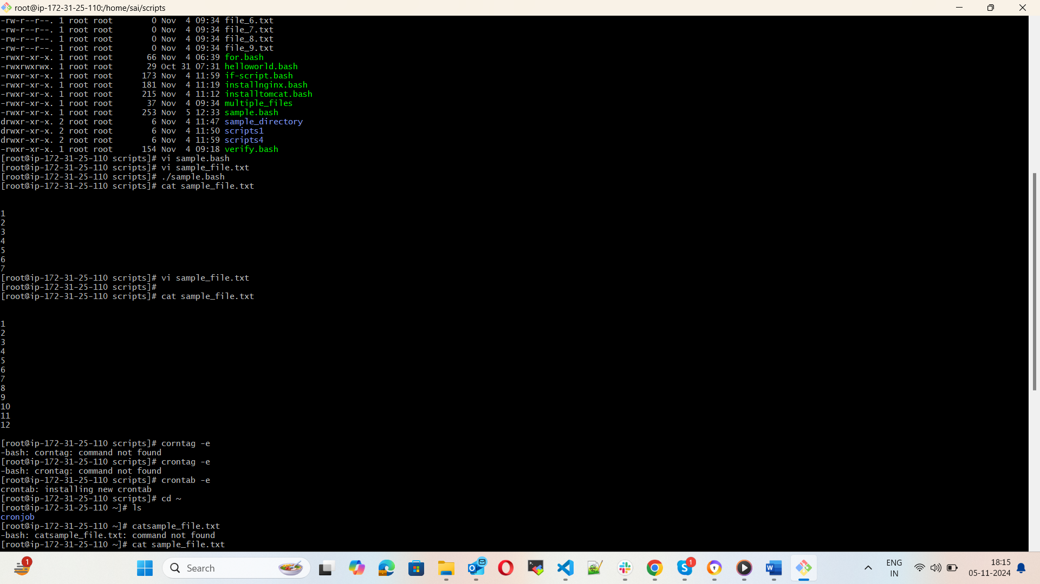



1. April 5th Midnight

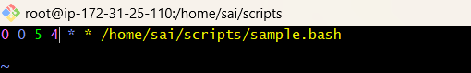

1. 5th of Every November, Jan, June if it is a Thursday.

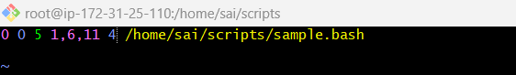

1. At 05 and 27th minutes of 9,10,11 hours every day.

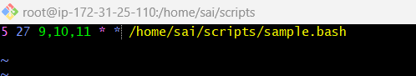

1. 34 min. of 9th hour on 15th Aug.

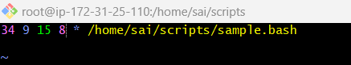

1. Every midnight

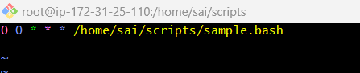

1. Every Weekend (Saturday night 11.59)

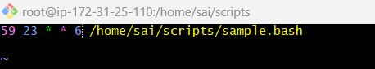

1. After every reboot

